Title of the Paper

First Author, Second Author, Third Author
Authors’ Affiliations
Corresponding author’s Email Address

Abstract
In this paper, the formatting requirements for the 1st International and the 3rd National Conference on Stone Industry: Exploration, Exploitation, Processing, and Marketing are described. Some recommendations for a worldwide readership are offered. Please review this document to learn about the formatting of text, table captions, and references. The conference papers will be published in an electronic format. The full paper in a MS Word file shall be written in compliance with these instructions. An abstract not exceeding 300 words should appear at the top of the first page, after the title of the paper in a section titled "Abstract" (without a section number), after the names of the authors.

Keywords: 4 - 6 keywords

1. Introduction

It is expected that authors will submit carefully written and proofread material. Careful checking for spelling and grammatical errors should be performed.
Papers should clearly describe the background of the subject, literature review, the author's work, including the methods used, results, and a concluding discussion on the importance of the work. Technical terms should be explained unless they are considered to be known to the conference community.

2. Paper Format

The uniform appearance will assist the reader in reading the paper of conference paper. It is therefore suggested to authors to use the example of this file to construct their papers. This particular example uses an American letter format with 25 mm margins left, right, top, and bottom.
All text paragraphs should be single-spaced. Double spacing should only be used before and after headings and subheadings as shown in this example. Position and style of headings and subheadings should follow this example. No spaces should be placed between paragraphs.

Fonts
Papers should use 11-point Times New Roman font. It is recommended that text in figures should not be smaller than an 11-point font size.

2.2 Tables and Figures
Figure captions and table headings should be sufficient to explain the figure or table without needing to refer to the text. Figures and tables not cited in the text should not be presented. The following is an example for Table 1.
Table 1 Title of the Table
Type of nanoparticles | Average size (nm) | Variance (nm)
CuO | 47 | 4.2
NiO | 35 | 6.4
Al₂O₃ | 42 | 2.1

Tables and figures should be placed close to their first reference in the text. All figures and tables should be numbered with Arabic numerals. Table headings should be centred above the tables.
Fig. captions should be centred below the figures as shown in Fig. 1.

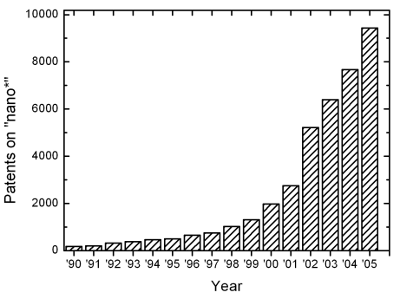
Fig. 1: Number of patents on nanotechnology with time

2.3 Equations
Each equation should be presented on a separate line from the text with a blank space above and below. Equations should be clear, and expressions used should be explained in the text. The equations should be numbered consecutively, as shown below. Here is one example.
In this case, the governing system of equations can be written as follows:
(1)
(2)
(3)

References
Proper references must be included throughout the text, and the list of references must be provided in this section. The references inserted in the text and the list of references should be done
as follows:
Reference citations: Citations in the main body, appendices, tables, and figures are to be made using the last name of the author (both authors when only two; first author plus et al. when more than two). Example: "... as previously shown (Jones et al., 2020)," or "... as shown by Jones et al. (2025)." For two or more papers published in the same year by the same author(s), add a, b, c, etc. to the year, such as (2024a) or (2024b), and cite jointly as Jones et al. (2024a, b).
List of references: List all cited references (including citations in tables, figures, and appendices) in alphabetical order according to the first-named author. The titles of papers, patents, and books, and the initial and final page numbers should be included.
Referencing websites: With the increasing availability of useful information that can be found on the internet, website references must also be reported. However, to avoid very long website addresses, these references should be referred to as Web-1, Web-2, etc. For example, in the body of the report:

“… it was shown that the heat transfer coefficient of nanofluids increased by 40% (Web-1) …”. In the reference list, provide the list of websites with the numerical values used in the text.

2.5 Conclusion
Conclusions should state concisely the most important propositions of the paper as well as the author’s views on the practical implications of the results.

2.6 Acknowledgements

A short acknowledgement section can be written between the conclusion and the references. Sponsorship and financial support acknowledgments should be included here. Acknowledging the contributions of other colleagues who are not included in the authorship of this paper is also added in this section. If no acknowledgement is necessary, this section should not appear in the paper.

2.7 References

References and citations should follow a consistent format (for example, the APA format). References should be set to 11-point, justified, with a single line spacing. References from online sources should add a site link too. The reference section at the end of the paper may be written based on the following format:

Rahimi, M., Chan, D., & Nouri, A. (2016). Bounding surface constitutive model for cemented sand under monotonic loading. International Journal of Geomechanics, 16(2), 04015049.

Rahimi, M., Chan, D., & Nouri, A. (2018). Constitutive model for monotonic and cyclic responses of loosely cemented sand formations. Journal of Rock Mechanics and Geotechnical Engineering, 10(4), 740-752.
Imam, M. R., & Chan, D. (2008). Application of a critical state model for the cyclic loading of sands. In Proc., 61st Canadian Geotechnical Conf (pp. 127-134).

Zoback, M. D., & Kohli, A. H. (2019). Unconventional reservoir geomechanics. Cambridge University Press.

